1. Creating script with “hello”?

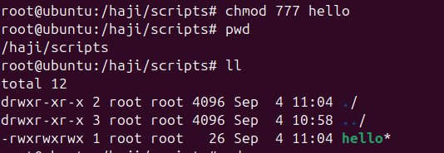

1. Create a script with .bash?

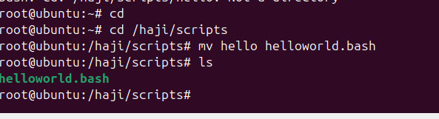

1. Using bin.bash show echo hello world?

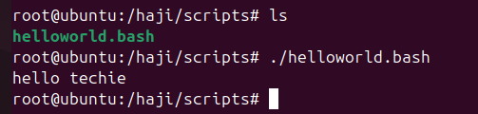

1. Define tasks ?

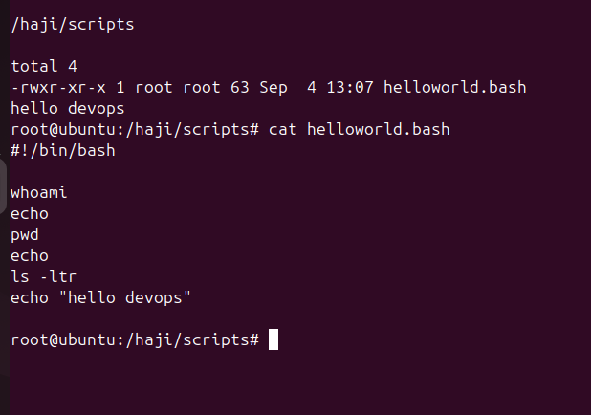

1. Defining variables ?

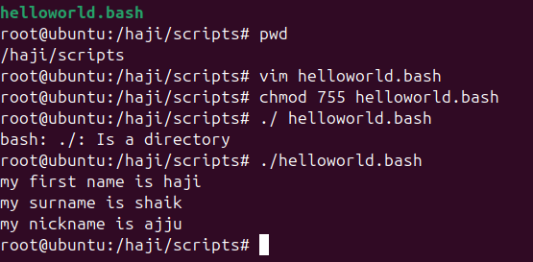

1. Read input ?

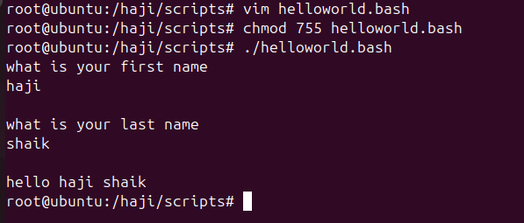

1. Scripts run in to command ?

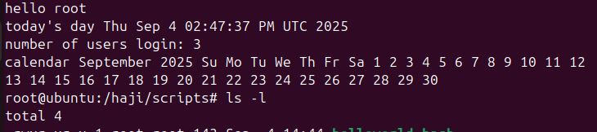

1. Read input nd operform a task ?

